**Project Planning Phase**

**Project Planning Template (Product Backlog, Sprint Planning, Stories, Story points)**

|  |  |
| --- | --- |
| Date | 26 june.2025 |
| Team ID | LTVIP2025TMID53135 |
| Project Name | LearnHUb:Your Center For Skill Enhancement |
| Maximum Marks | 5 Marks |

**Product Backlog, Sprint Schedule, and Estimation (4 Marks)**

**Product Backlog Example**

| **Sprint** | **Epic** | **USN** | **Task** | **Story Points** | **Priority** | **Team Member** |
| --- | --- | --- | --- | --- | --- | --- |
| Sprint-1 | Registration | USN-1 | Register with email/password | 2 | High | [Member A] |
| Sprint-1 | Registration | USN-2 | Confirm via email | 1 | High | [Member A] |
| Sprint-1 | Registration | USN-3 | Register with Gmail | 2 | Medium | [Member B] |
| Sprint-1 | Login | USN-4 | Login | 2 | High | [Member B] |
| Sprint-1 | Role Setup | USN-5 | Setup user roles | 2 | Medium | [Member A] |

| Sprint-2 | Catalog | USN-6 | Browse courses | 3 | High | [Member C] |  
| Sprint-2 | Catalog | USN-7 | Search courses | 2 | High | [Member C] |  
| Sprint-2 | Enrollment | USN-8 | Enroll in a course | 2 | High | [Member A] |  
| Sprint-2 | Dashboard | USN-9 | Show enrolled course list | 2 | Medium | [Member B] |

**✅ Sprint Tracker and Velocity Table**

| **Sprint** | **Total Story Points** | **Duration** | **Start Date** | **End Date** | **Completed** | **Release Date** |
| --- | --- | --- | --- | --- | --- | --- |
| Sprint-1 | 11 | 6 days | 01 Mar 2025 | 06 Mar 2025 | 11 | 06 Mar 2025 |
| Sprint-2 | 12 | 6 days | 08 Mar 2025 | 13 Mar 2025 | 12 | 13 Mar 2025 |

📈 **Velocity:** (11 + 12) / 2 = **11.5 story points/sprint**

**✅ Burndown Chart**

For the burndown chart:

* **X-axis:** Sprint days (e.g., Day 1 to Day 6)
* **Y-axis:** Remaining story points (e.g., Start with 12 → Burn down to 0)
* You can use Excel or a tool like Jira, Trello, or Visual Paradigm to generate this chart.
* 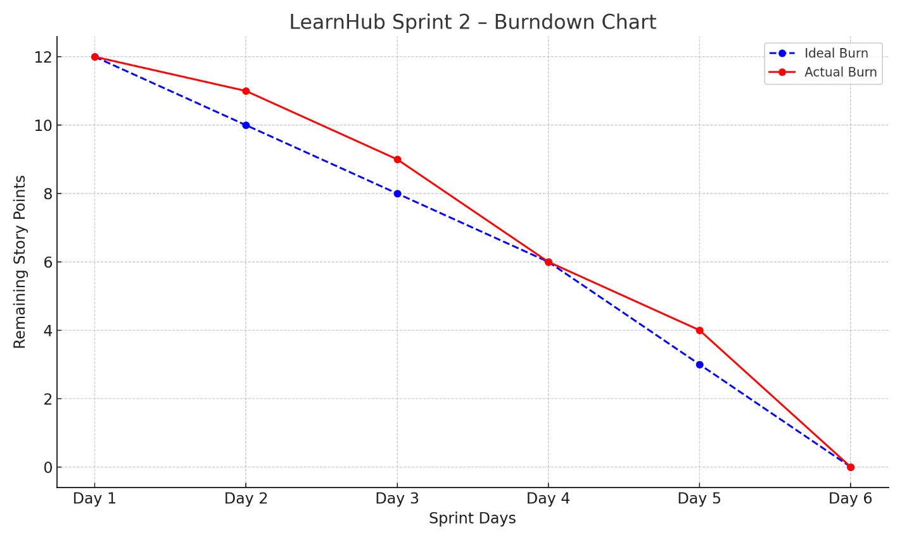

[**https://www.visual-paradigm.com/scrum/scrum-burndown-chart/**](https://www.visual-paradigm.com/scrum/scrum-burndown-chart/)

[**https://www.atlassian.com/agile/tutorials/burndown-charts**](https://www.atlassian.com/agile/tutorials/burndown-charts)

**Reference:**

[**https://www.atlassian.com/agile/project-management**](https://www.atlassian.com/agile/project-management)

[**https://www.atlassian.com/agile/tutorials/how-to-do-scrum-with-jira-software**](https://www.atlassian.com/agile/tutorials/how-to-do-scrum-with-jira-software)

[**https://www.atlassian.com/agile/tutorials/epics**](https://www.atlassian.com/agile/tutorials/epics)

[**https://www.atlassian.com/agile/tutorials/sprints**](https://www.atlassian.com/agile/tutorials/sprints)

[**https://www.atlassian.com/agile/project-management/estimation**](https://www.atlassian.com/agile/project-management/estimation)

[**https://www.atlassian.com/agile/tutorials/burndown-charts**](https://www.atlassian.com/agile/tutorials/burndown-charts)